INCIDENT PROCEDURE
To be displayed near each workstation

If you suspect a cyberattack, a loss of data or any unusual behaviour on your computer, follow these 6 steps in order. Do not panic. Every minute counts.

1. ISOLATE
Immediately unplug the network cable from the computer concerned. Turn off the WiFi. Do not touch the keyboard or the mouse again. DO NOT SWITCH OFF the computer; that would destroy the evidence needed for the analysis.

2. ALERT
Inform the head of the practice (or their designated deputy) immediately. Do not try to solve the problem on your own.

3. CALL THE IT PROVIDER
The head of the practice or the designated person contacts the IT provider urgently. If the provider is unavailable, contact the FOCS via incidents@ncsc.ch or the form at report.ncsc.admin.ch.

4. DO NOT PAY
If a ransom message appears on the screen, never pay. This is the official recommendation of the Swiss Confederation. Paying does not guarantee that the data will be recovered and finances criminal networks.

5. DOCUMENT
Photograph the error or ransom screens with a phone. Note the exact time of discovery. Describe the symptoms observed. List the computers that appear to be affected. Keep everything.

6. ASSESS AND NOTIFY
The head of the practice assesses whether the breach is likely to result in a high risk for patients. If so, or if they cannot rule it out quickly, they report the breach to the FDPIC as soon as possible (Art. 24 para. 1 FADP) via databreach.edoeb.admin.ch.
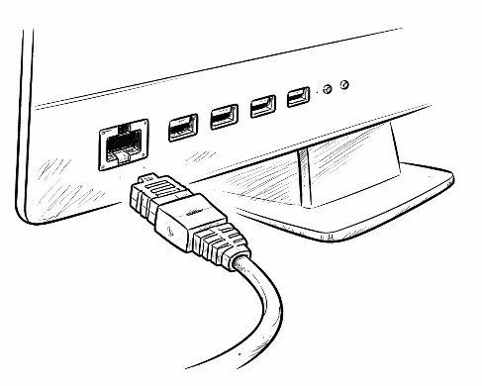
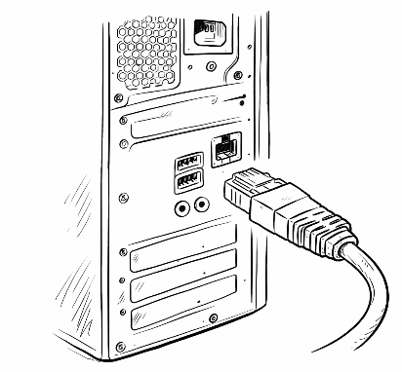
Ethernet cable in front of an Ethernet port on a workstation | example only. The location may vary from one computer to another.

Emergency contacts

The practice's IT provider | [Name] | [Phone] | [E-mail]
Head of the practice | [Name] | [Phone]
FOCS (Federal Office for Cyber Security) | incidents@ncsc.ch | report.ncsc.admin.ch
FDPIC (notification of a data breach) | +41 58 462 43 95 (Mon-Fri 10:00-12:00) | databreach.edoeb.admin.ch
Cantonal police | 117

This document complements the practice's internal IT security policy. It must be printed, completed with the contact details of the IT provider and the head of the practice, and displayed near each workstation.

Legal notice and terms of use
This document was written by DentalSystems Sàrl for information and awareness purposes. It does not constitute legal advice. The information in this document is up to date as of March 2026 and may change as legislation and regulations evolve. This English version is a translation; the French version prevails.
For any legal question relating to the FADP, the GDPR or data protection in the medical context, consult a lawyer specialising in the field.

Intellectual property
This document is the exclusive property of DentalSystems Sàrl. All of its content (texts, structure, layout and graphic elements) is protected by copyright in accordance with the Federal Act on Copyright and Related Rights (CopA, SR 231.1).

Permitted use
This template is made available free of charge. It may be modified and used under the practice's name, including with its patients, staff and providers, without keeping our references.

Prohibited use
Unless DentalSystems Sàrl has given its prior written consent, the following are prohibited:
– Selling this document, even in modified form.
– Offering it for download to third parties (download sites, sharing platforms, resellers).
The terms of use published on www.dentalsystems.ch apply; in the event of a discrepancy, they prevail over this notice.

Limitation of liability
This document is provided free of charge, for information. To the extent permitted by Swiss law, DentalSystems Sàrl is not liable for the consequences of its use; this limitation does not apply in the event of intent or gross negligence. Users remain responsible for adapting it to their situation. It replaces neither a professional audit nor legal advice.
DentalSystems Sàrl
Thomas Alvino, IT Technician
www.dentalsystems.ch | talvino@dentalsystems.ch | +41 77 245 48 44
© 2026 DentalSystems Sàrl. All rights reserved.

